**Task1: Becoming a Certificate Authority (CA)**

In order to use OpenSSL to create certificates we need a config file which is openssl.conf, I make a copy of openssl.conf to my current directory which is ‘/home/seed/Desktop/lab4’ and I named it by openssl1.com. I also create a sub-directory which is called demoCA, it contains certs, ctl, newcerts, index.txt and serial.

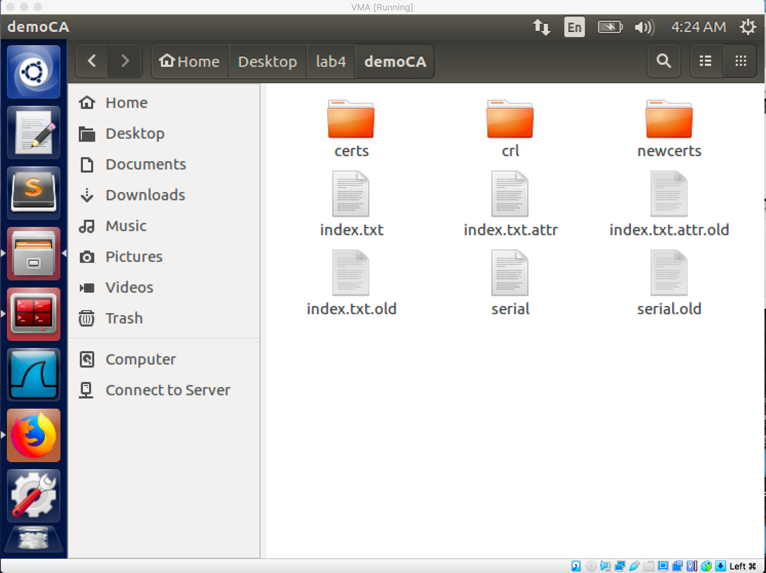

After create the directory, I use the command ‘ openssl req -new -x509 -keyout ca.key -out ca.crt -config openssl1.cnf’ to generate a self-signed certificate for the CA. Two file will be generated, ca.key contains the private key of the CA, ca.crt contains the public key of the CA.

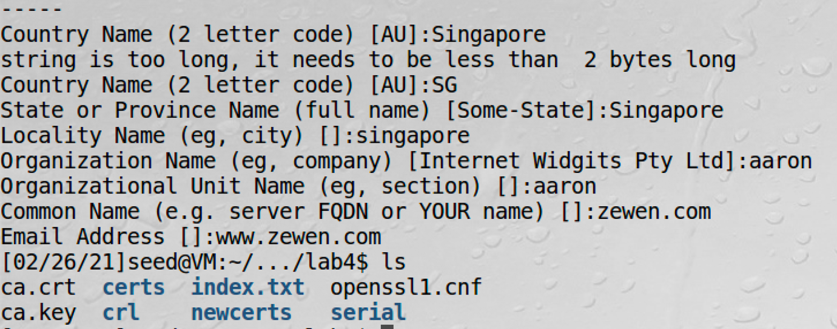

**Task2: Creating a Certificate for SEEDPKILab2020.com**

Step1:

I use command ‘ openssl genrsa -aes128 -out server.key 1024’ to generate a public/private key pair which encrypted by aes128 algorithm. A server.key file will be outputted. We can check the modulo, exponent by using command ‘﻿openssl rsa -in server.key -text’.

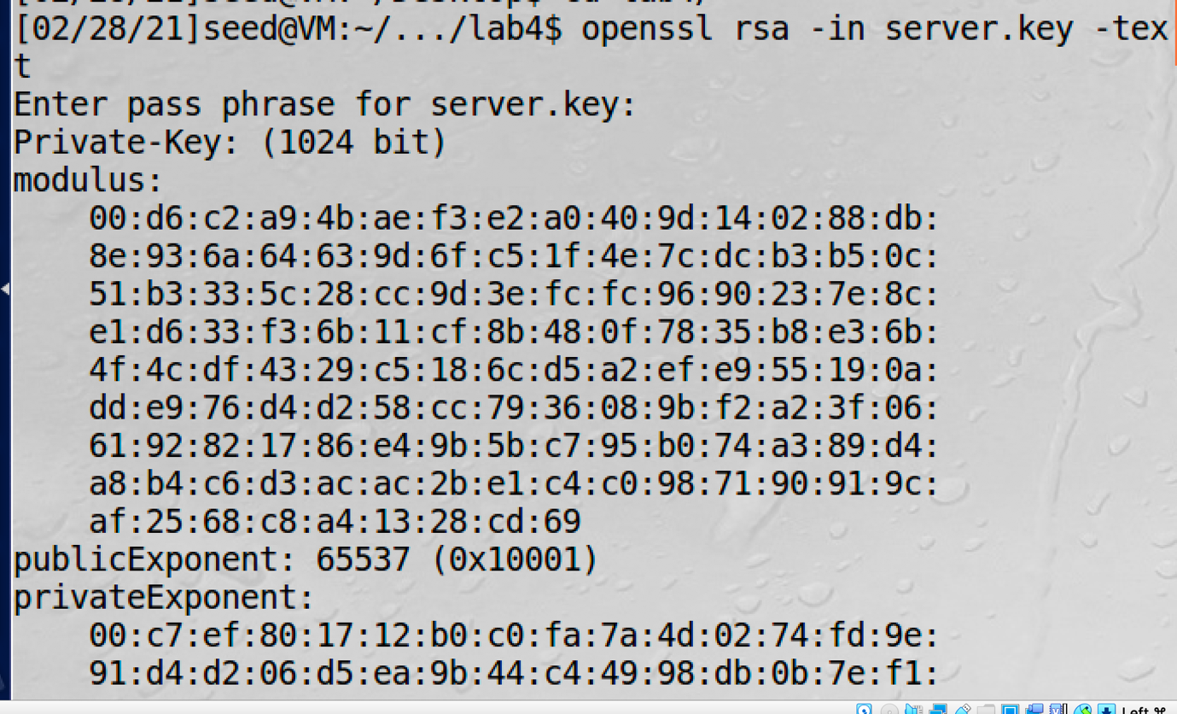

Step2:

I use command ‘openssl req -new -key server.key -out server.csr -config openssl1.cnf’ to generate a request to sign file for ‘SEEDPKILab2020.com’. A ‘server.csr’ file will be generated.

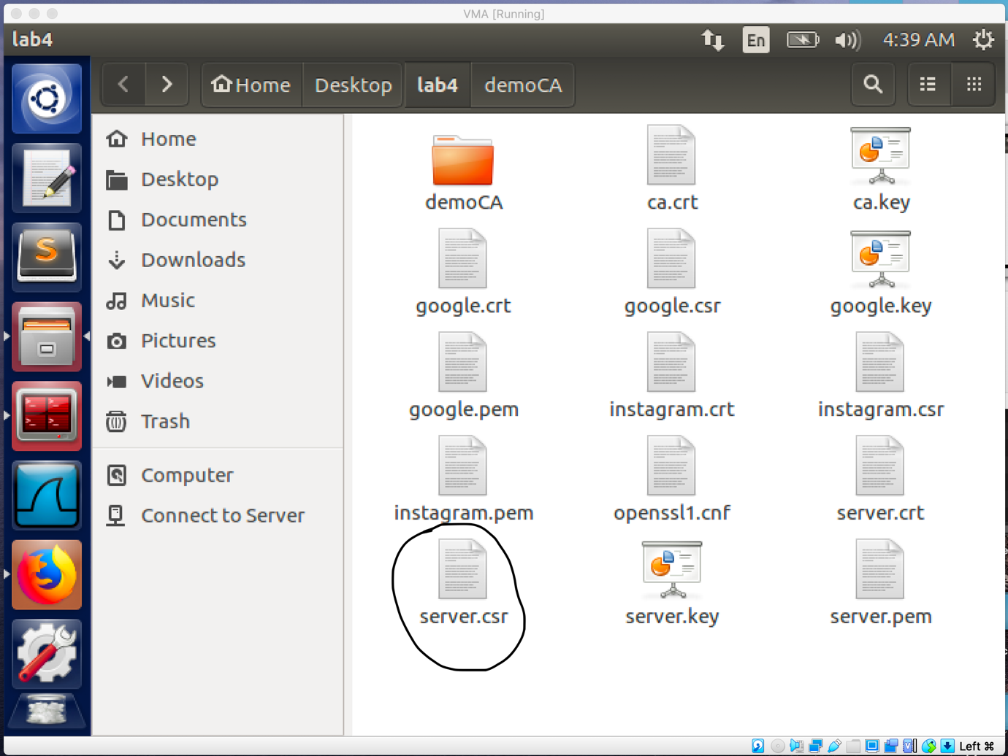

Step3:

I use command ‘ openssl ca -in server.csr -out server.crt -cert ca.crt -keyfile ca.key -config openssl1.cnf’ to send the csr file to the CA and ask for signing the certificate. A file called server.crt will be generated which is the signed certificate of our server.

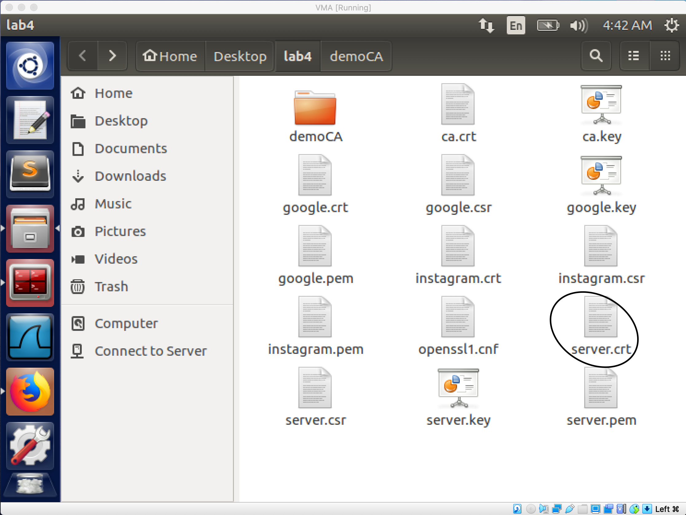

**Task3: Deploying Certificate in an HTTPs web server**

Step1:

We choose SEEDPKILab202.com as the name of our website. To get the VM recognize this name, I add the ‘ 127.0.0.1 SEEDPKILab2020.com’ entry to my ‘/etc/hosts’ file.

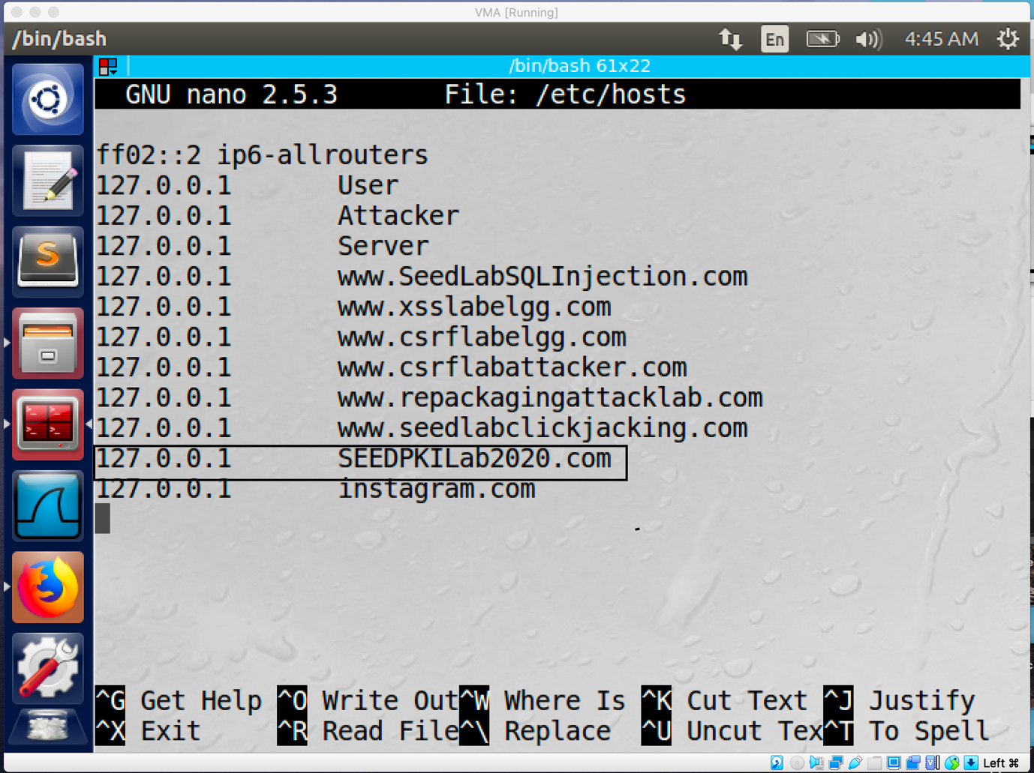

Step2: Configuring the web server

I combine the secret key and certificate into one file by using command ‘cp server.key server.pem’ and command ‘ cat server.crt >> server.pem’. 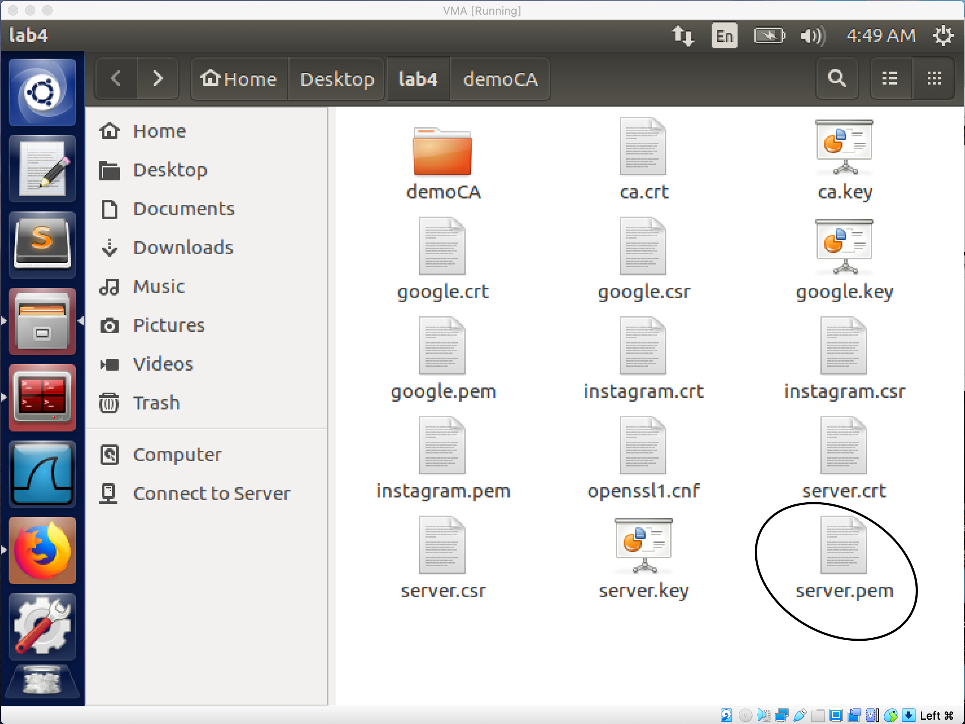

After that I use the command ‘ openssl s_server -cert server.pem -www’ to start a simple web server.

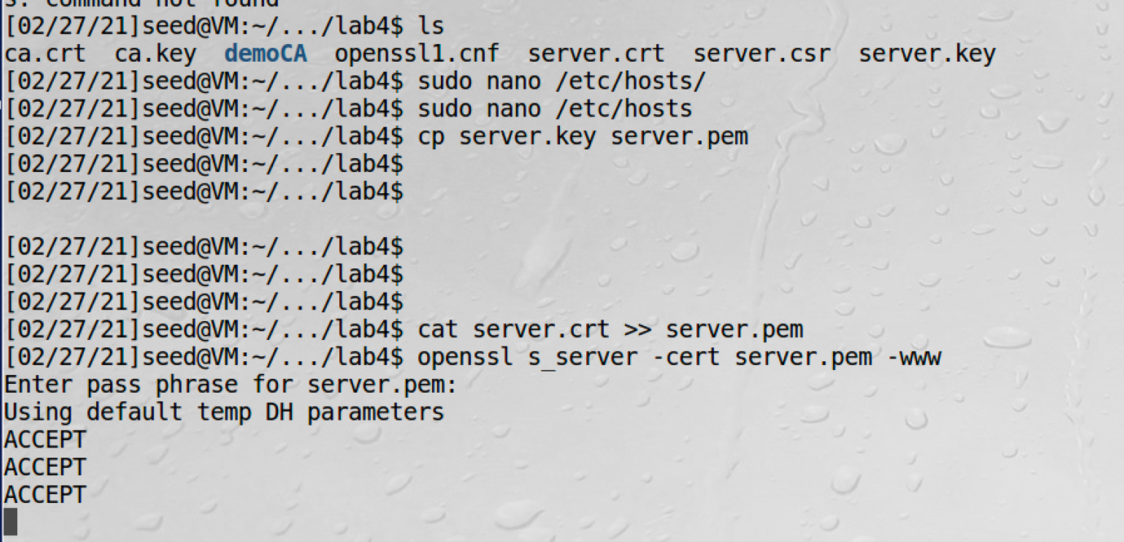

By searching the URL ‘ SEEDPKILab2020.com’ on Firefox I was blocked because the certificate is self-signed.

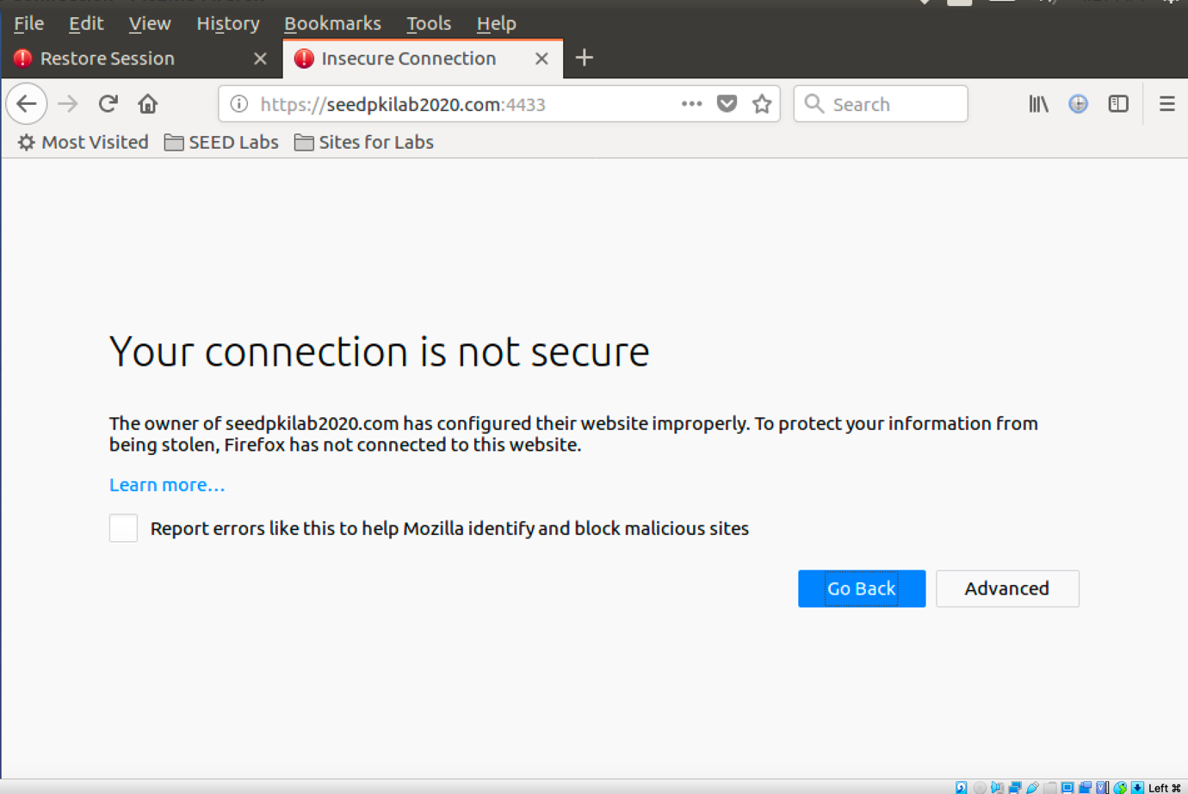

Step3: Getting the browser to accept our CA certificate

Since our self-signed is not include into our Firefox server, I manually add the ca.crt to the Firefox.

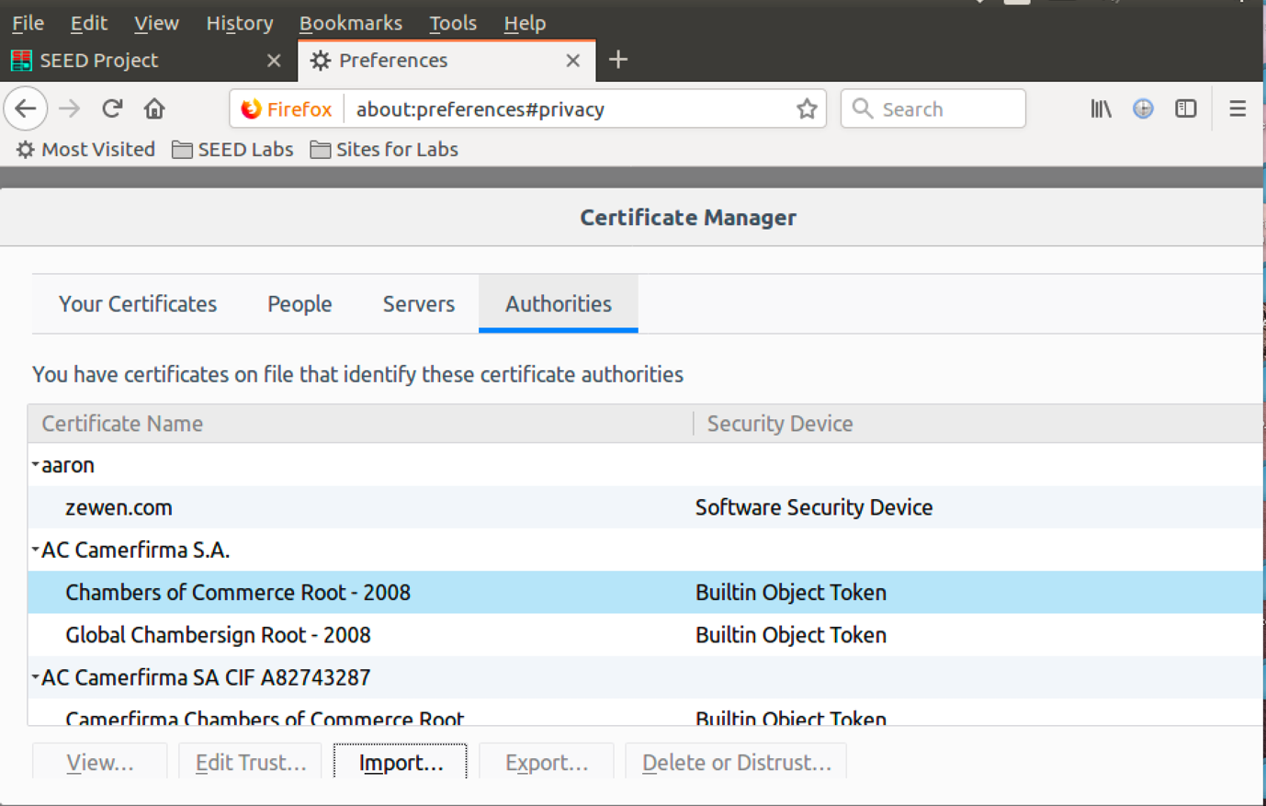

Step4: Testing our HTTPS website

After adding the ca.crt to the Firefox server, I am able to visit the website.

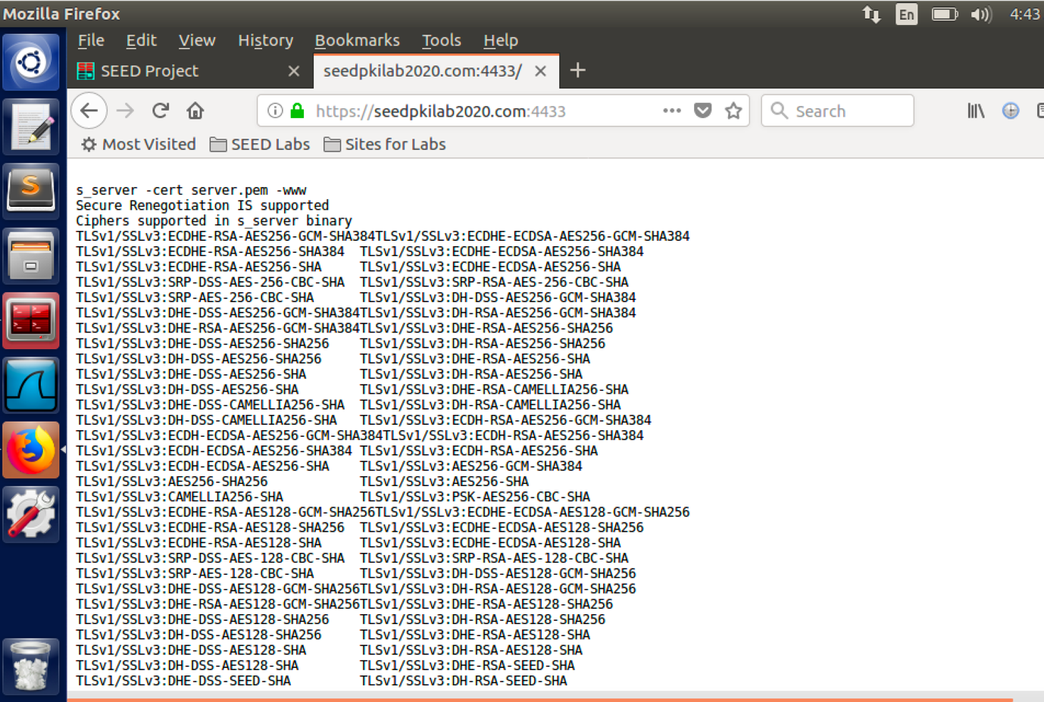

* When I modify one byte of the server.pem file, I am not able to connect to the website. It is because the server.pem is corrupted so the web browser cannot authenticate the server’s certificate.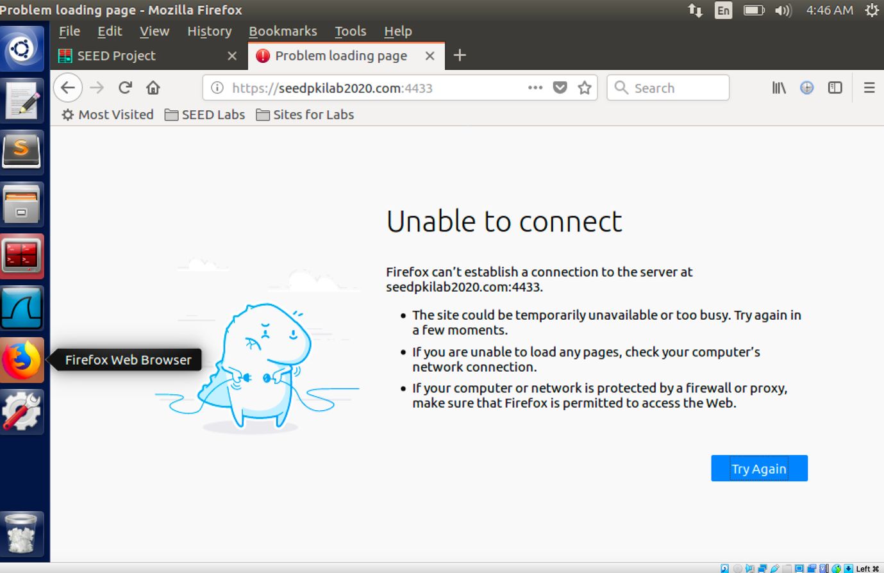
* If I change the URL to ‘localhost:4433’ I am not able to connect to the website, since Firefox will check the CN in the certificate, it will find out the CN is SEEDPKILab2020.com not localhost, so it will not establish the connection.

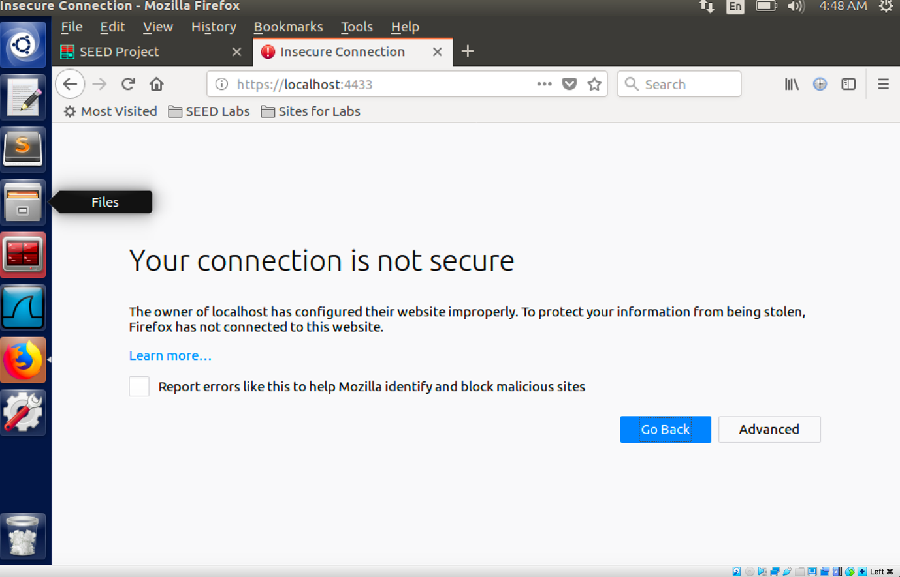

Task4: Deploying Certificate in an Apache-Based HTTPS Website

In order to add a HTTPS website to the server, I add a HTTPS web server to the ‘/etc/apache2/sites-available/default-ssl.conf’ directory.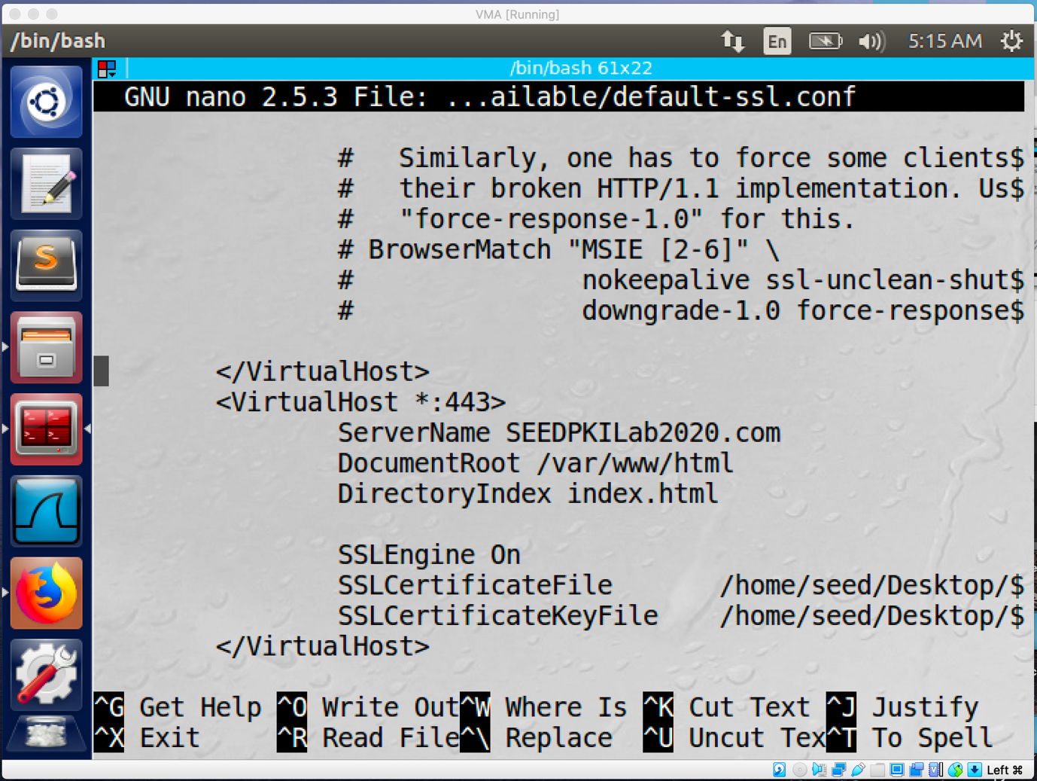

After add the server to default-ssl.conf file, I run server command to restart the service.

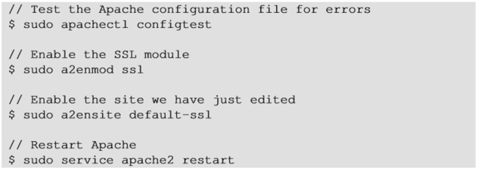

Then I am able to visit the SEEDPKILab2020.com under https request.

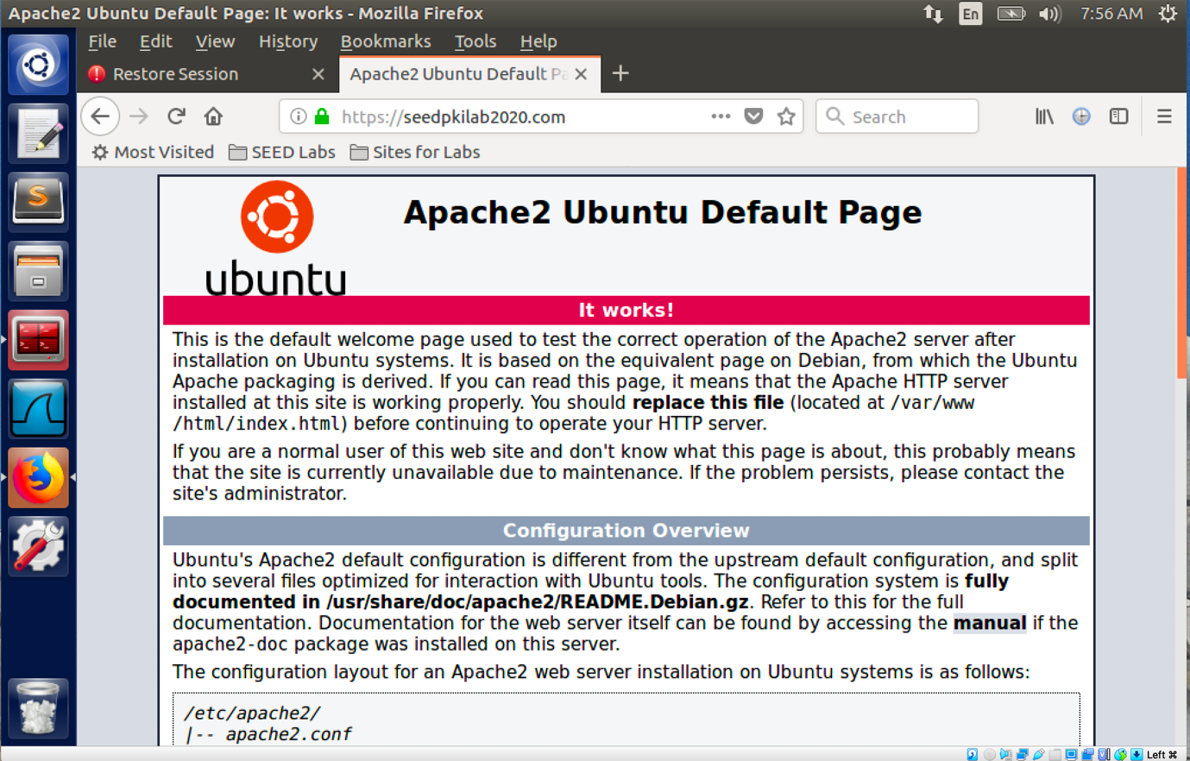

**Task5: Man-In-The-Middle Attack**

Step1: Setting up the malicious website.

Followed the task 4 procedure, I add another HTTPS web server to the default-ssl.conf file for Instagram.com.

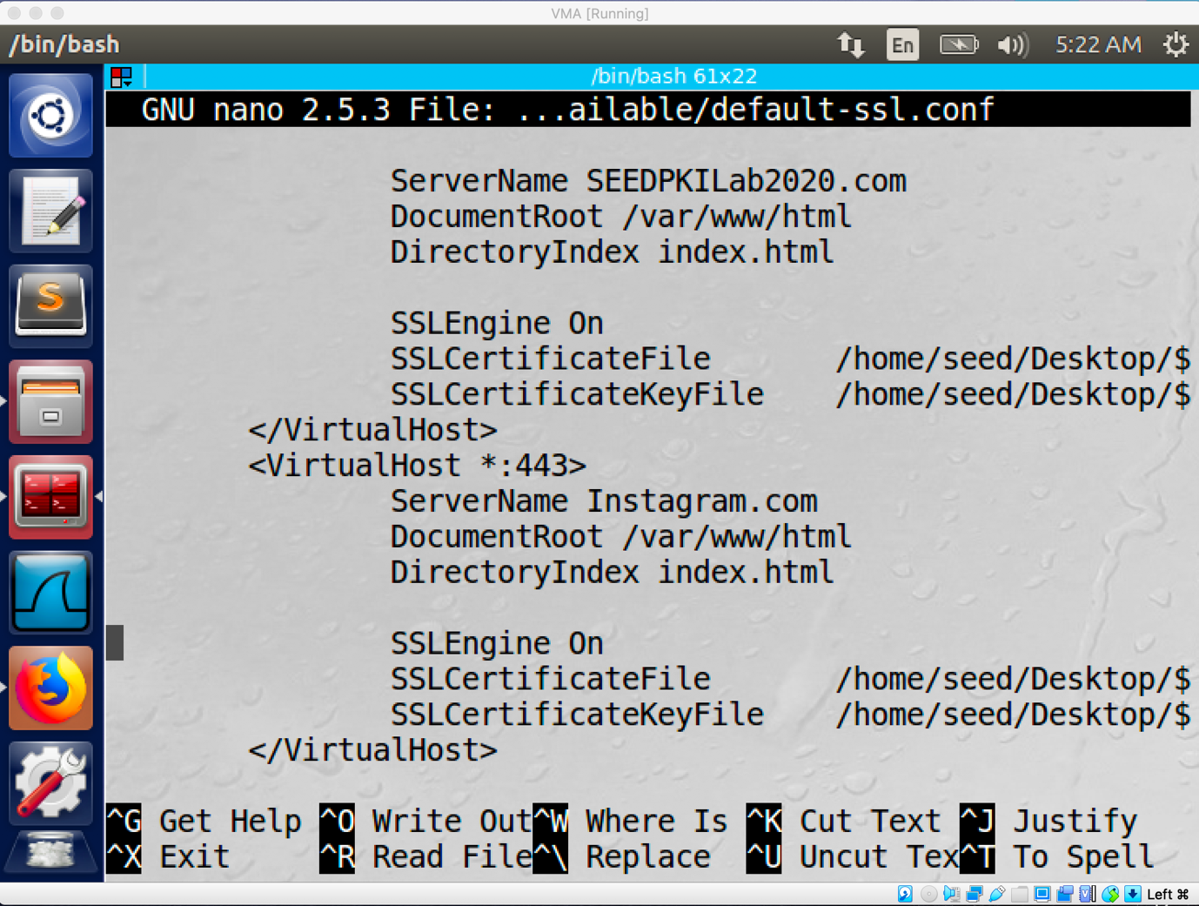

Step2:

After that I add the entry ‘10.0.2.7 instagram.com’ to another vm. The 10.0.2.7 Is the ip address of the man-in-the-middle.

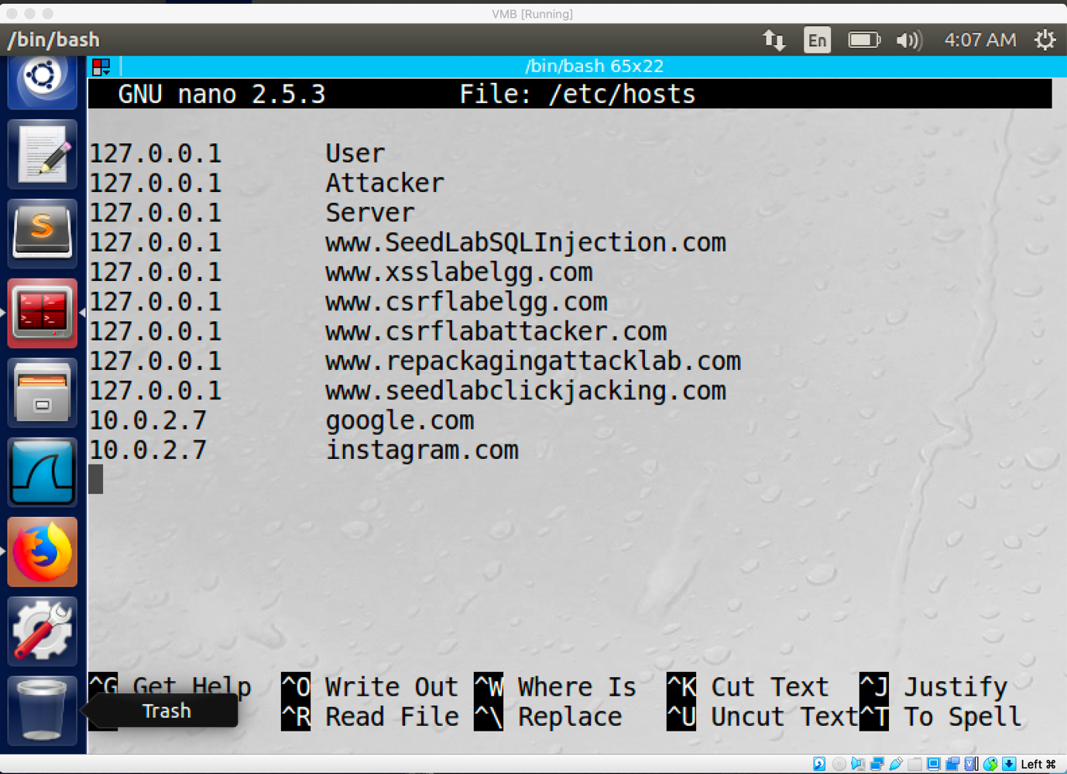

Step3: Browse the target website

By searching the URL Instagram.com on the victim machine, I will go to the malicious website.

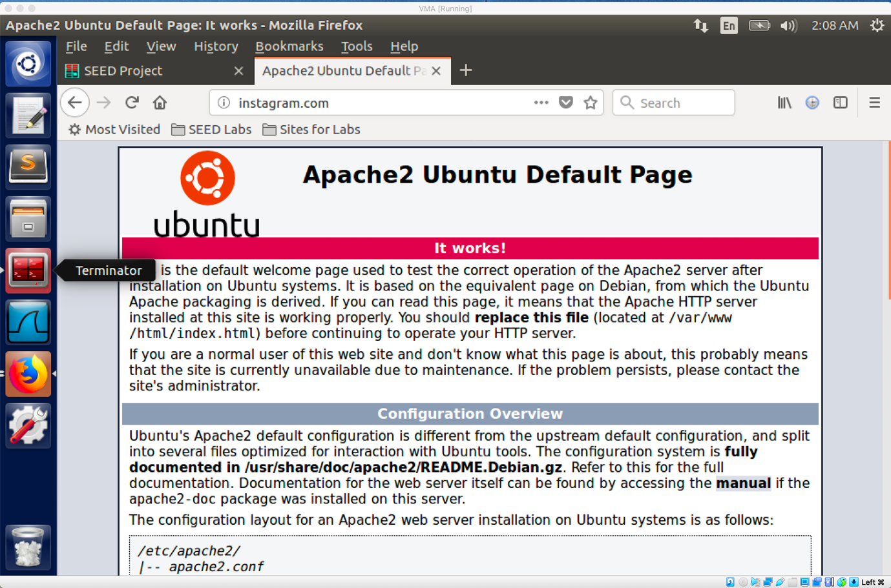

**Task6: Launching a Man-In-The-Middle Attack with a Compromised CA**

Step1:

I using my CA to signed a certificate for Instagram.com by using command ‘﻿openssl req -new -key server.key -out instagram.csr -config openssl1.cnf’ and command ‘﻿openssl ca -in instagram.csr -out instagram.crt -cert ca.crt -keyfile ca.key -config openssl1.cnf’.

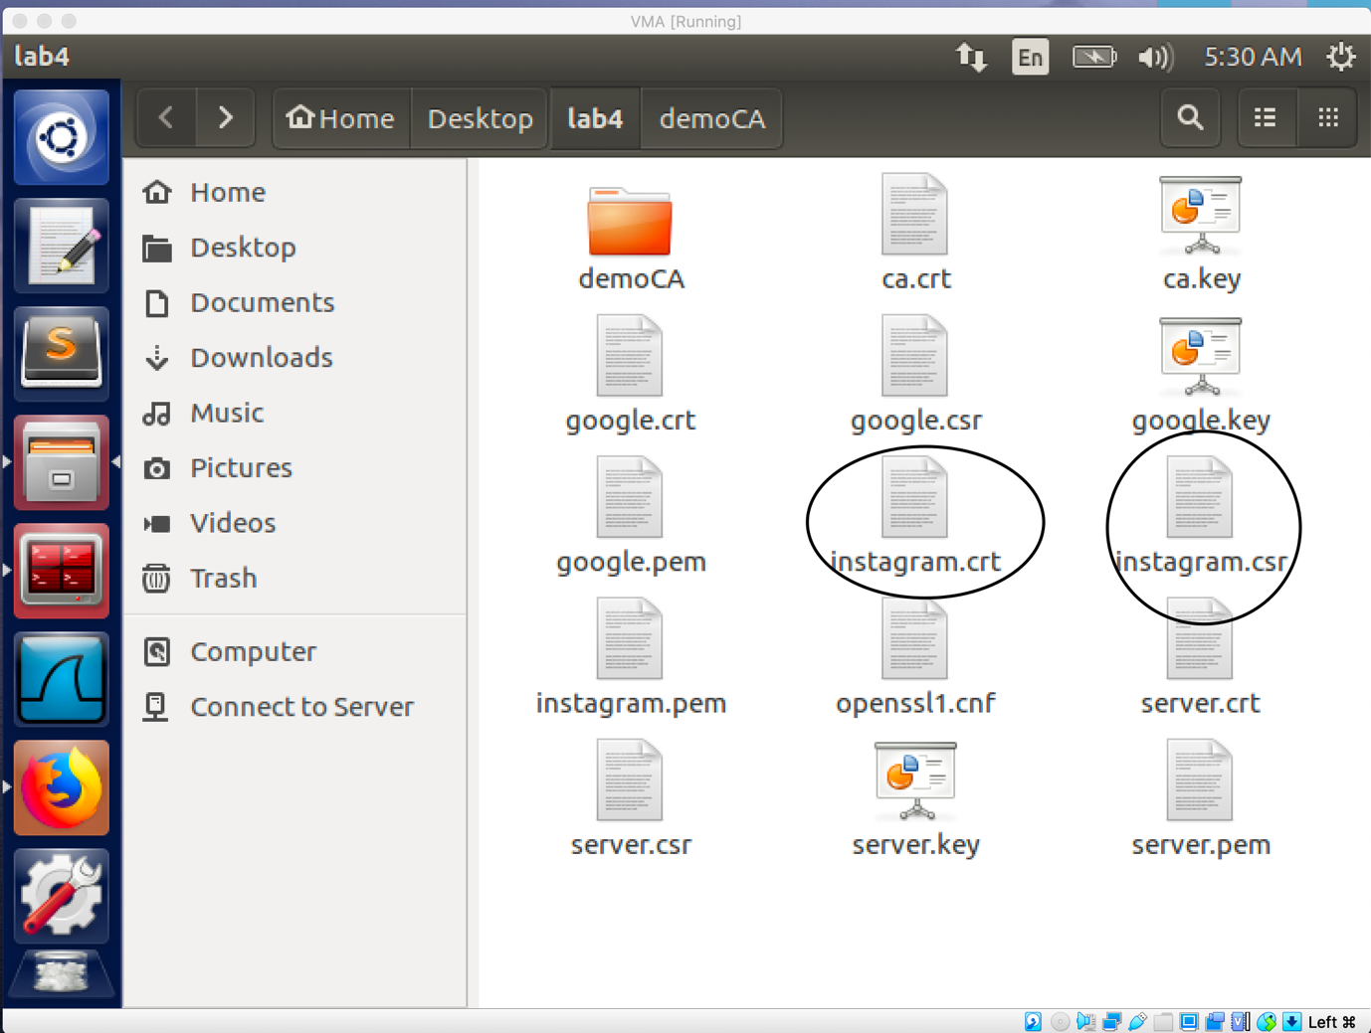

Step2:

I send the ca.crt file to the victim machine by using command ‘scp [seed@10.0.2.7:/home/seed/Desktop/lab4/ca.crt](mailto:seed@10.0.2.7:/home/seed/Desktop/lab4/ca.crt) /home/seed/Desktop’

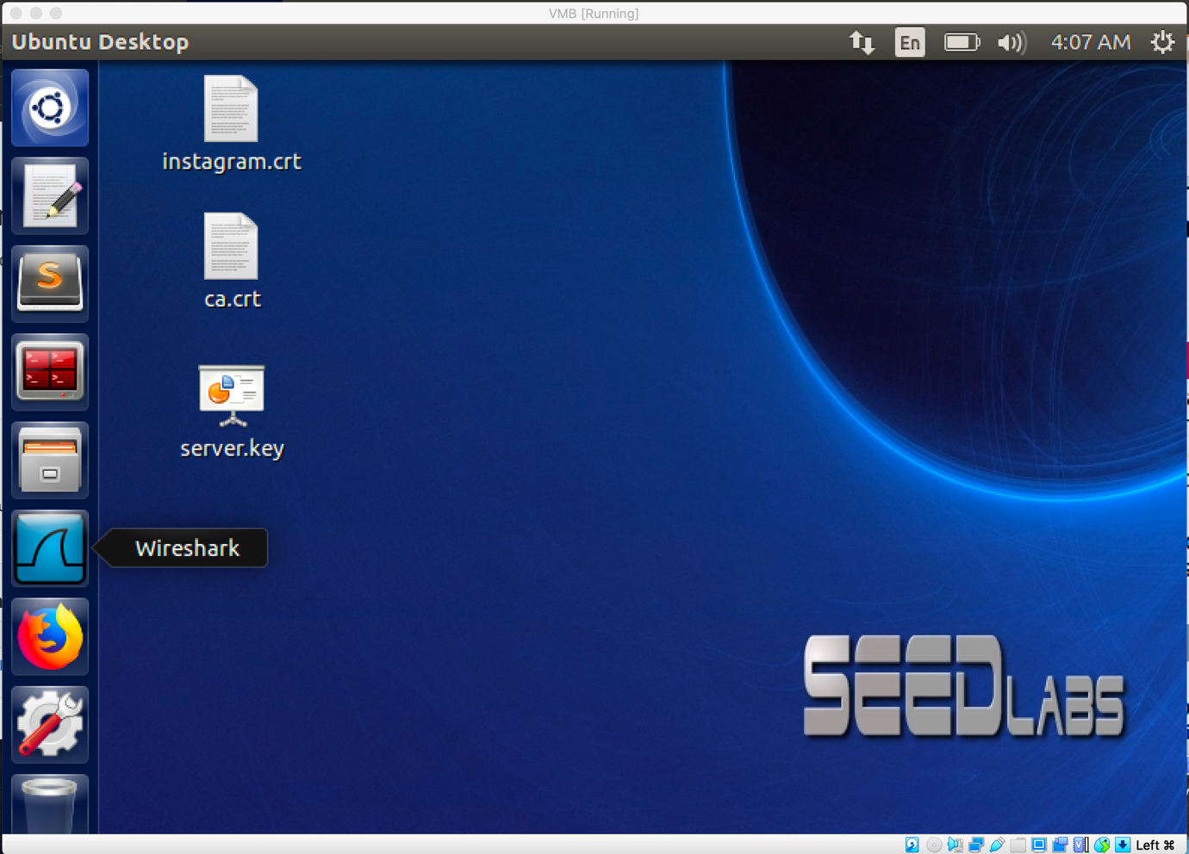

Step3:

I add the ca.crt file to the truested ca list of Firefox.

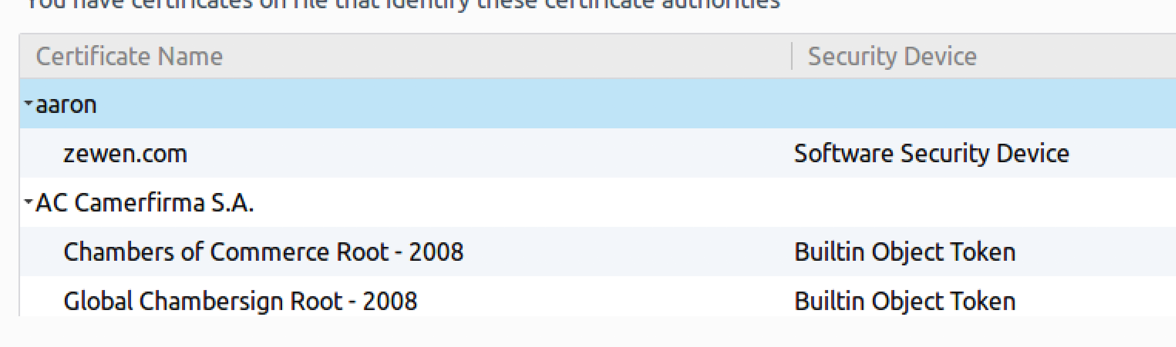

Step4:

After configuration, I am able to visit the target website under https request at the victim machine. Which means, if the DNS attack is successful I am able to set up the man-in-the-middle attack.

